Updated 9/29/2019

HLA Diagram

Web Server/Host

User Database

Snapchat API

Payment Processor

HLA Diagram v2:

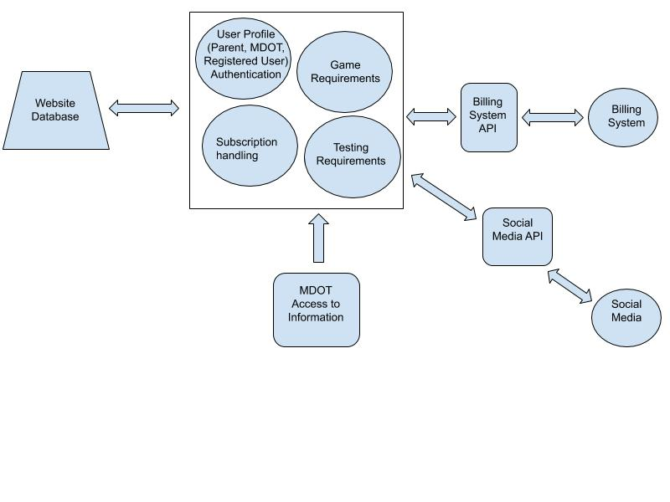

Class Diagram

|  |
| --- |
| User |
| String name  String email  String birthday  String address  Boolean subscriber  Boolean underaged  User ParentAccount  Pointer Facebook  changeName/email/birthday…()  cancelAccount()  cancelSubscription()  getScores() |

|  |
| --- |
| DataReport |
| String query  retrieveData()  viewData()  generateReport() |

|  |
| --- |
| Game |
| double scores  User player  openGame()  closeGame()  pauseGame()  storeScores() |

|  |
| --- |
| Parent Extends User |
| User childAccount  linkChildAccount()  getChildData() |

|  |
| --- |
| MVA_user |
| accessData()  retrieveData() |

Interface Specification

|  |  |  |
| --- | --- | --- |
| <<Facebook Interface>> | <<Game Interface>> | <<DataBase Interface>> |
| linkUser()  shareProgress() | selectGame()  startGame(Game Object)  endGame(Game object)  storeData(string)  pauseGame(Game object) | Connect()  Disconnect()  collectData(Query): string  printData(Data): Report  generateQuery(String): string |

|  |
| --- |
| <<Admin Interface>> |
| configureUser(User object)  deleteUser(User object)  createUser(): user  alterDatabase(Database) |

|  |
| --- |
| <<PaymentProcessor Interface>> |
| LinkAccount()  cancelSubscription()  subscribe()  processPayment() |